

**FI4008 Individual Data Analysis Assignment:**

**Name:** Michael Tuohy

**Introduction:**

Advanced Micro Devices Inc. (AMD) is the asset I've decided to analyse. AMD is a multinational semiconductor corporation headquartered in Santa Clara, California. AMD began its journey in 1969 as a Silicon Valley start-up with hundreds of employees focusing on cutting-edge semiconductor devices.

AMD has developed from humble origins to become a global firm that sets the standard for modern computing through major technology breakthroughs and several industry firsts (Advanced Micro Devices 2022). AMD provides a comprehensive spectrum of high-performance and adaptive processor technologies, integrating CPUs, GPUs, FPGAs, Adaptive SoCs, and deep software expertise to allow cloud, edge, and end-device computing platforms (Advanced Micro Devices 2022)

AMD's sales in 2020 was $9.76 billion, with a net income of $2.49 billion in the same year. AMD plans to spend $1.98 billion on research and development (R&D) in 2020 as it seeks to improve its product range (Alsop 2021). AMD processors commanded a market share of 24.6 percent, the largest in 15 years (White 2021). AMD debuted on the New York Stock Exchange (NYSE) in 1979 and announced its move to the Nasdaq in 2014 (Prairie and Cotter 2014).

**Price Evolution:**

(Fig 1.)

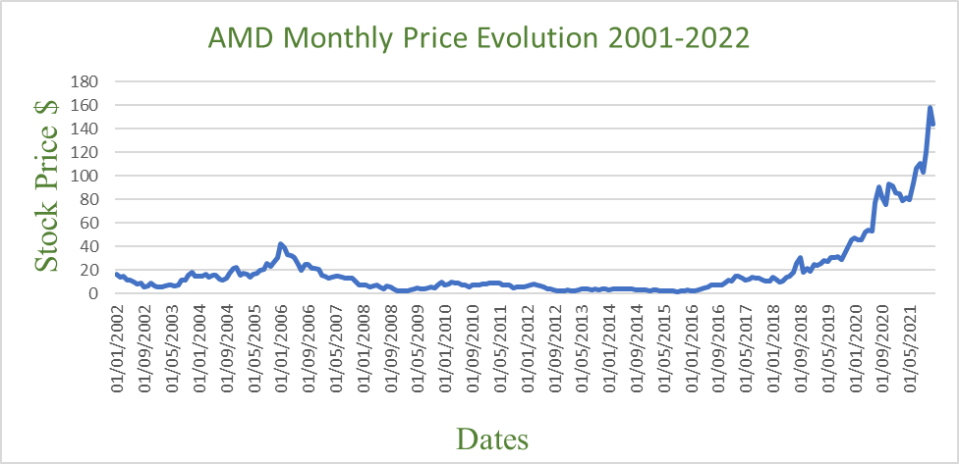

The graph above represents the stock price evolution of AMD from 31/12/2001 to 31/12/2021. Since 2001 there has been a steady increase in the stock price rising from $16.05 a share to $143.90 a share over the past 20 years. The stock looks very attractive at first inspection as a result of the exponential increase over the last 20 years, but the semiconductor industry can be very unpredictable. The semiconductor industry has had a history of supply shortages, which has impacted the volume of sales greatly for semiconductor dependent industries (Baraniuk 2022).

Semiconductor manufacturing has seen a generalized decay in capital expenditure over the past twenty years and at the same time, capital equipment that relies on semiconductors has experienced an exponential increase in demand (Amarnath and Williams 2021). This can be seen in the above graph as AMD has experienced a sharp increase from 2016 to present.

AMD has experienced noticeable dips in stock price during both the Global Financial Crisis and the Covid-19 pandemic. Although AMD stock has rebounded very quickly from the Covid-19 dip, there is uncertainty on whether it can continue its upward trend following the further aggravation of supply chain issues, as a result of the pandemic (Knight 2021).

On analysis of AMD return over the past twenty years, it can be seen that they have experienced volatility compared to the Nasdaq (Fig 2). Although, AMD is suffering from supply chain issues as a result of covid, volatility has slightly decreased during this period (Fig 3). The decrease in trading volume over the covid period may be a contributing factor to the decrease in volatility (Fig 4). The more buyers and sellers interested in a given stock, the more liquid the market will be. The amount of liquidity in a market can have a significant impact on how quickly stock prices can move in either direction (Motley Fool 2016).

**Summary Returns:**

(Fig 5.)



(Fig 6.)

|  |  |  |
| --- | --- | --- |
| **Weekly** | **Nasdaq** | **AMD** |
| Mean | 0.001950047 | 0.001900322 |
| Standard deviation | 0.027473345 | 0.081604967 |
| Variance | 0.000754785 | 0.006659371 |
| Skewness | -0.579259322 | -0.132094497 |
| Kurtosis | 3.234825914 | 3.100747048 |
| Observations | 1042 | 1042 |

(Fig 7.)



Over the last two decades, summary statistics for AMD have been collected on a monthly, weekly, and daily basis. The above figures can be used to compare AMD's performance to that of the Nasdaq, as well as to assess the riskiness of AMD as an investment.

**Mean:**

The mean return of a stock compares AMD's daily, weekly, and monthly returns to the Nasdaq's average returns. A stock with a mean similar or higher than the Nasdaq would indicate that it is performing better than the benchmark index, whereas one with a mean less than the Nasdaq is underperforming and will be riskier for investors.

AMD’s mean figures (Monthly to daily) are 0.91%, 0.190%, 0.043% while the Nasdaq where slightly lower overall (0.87%, 0.195% and 0.43%). The figures show that there are greater mean returns on a monthly basis compared to the smaller weekly changes and the even smaller daily changes. The mean statistics show that AMD has performed slightly better than the market over the past 20 years and has been quite closely linked to the market. This indicates that the stock is relatively safe as it is closely linked to the benchmark index.

**Standard Deviation and Variance:**

The standard deviation is a measure that indicates how much the values of a set of data deviate from the mean. Variance is equal to the standard deviation squared, it also measures the spread of a dataset and how far they are from the mean. Variance is used to determine both volatility and market security (CFI 2022).

A high standard deviation is prone to violent price moves and represents a higher level of risk, as the stock could go up or down unexpectedly. A low standard deviation stock would experience less volatility and would be easier to predict, therefore it would carry less risk. The variance can be square rooted to get the standard deviation of returns, which would be more useful to interpret the volatility of the returns.

From looking at the tables above it can be see that the Nasdaq’s standard deviation results where 5.1%, 2.7% and 1.3%. These figures indicate that the Nasdaq returns fluctuate by approximately 5.1% on a monthly basis, 2.7% on a weekly basis and 1.3% on daily basis. fluctuations increase on a monthly basis and how smaller weekly and daily fluctuations accumulate over time and cause further deviations away from the mean. AMD figures where significantly higher (17.3%, 8.1% and 3.7% ), illustrating that AMD is more prone to violent price movements and is subject to a higher level of risk.

**Skewness and Kurtosis:**

Histograms will be used along with the summary return statistics to illustrate whether there is skewness and kurtosis present in AMD or the Nasdaq and how it effects the volatility of a stock. Skewness is a measure of symmetry, a distribution, or data set, is symmetric if it looks the same to the left and right of the centre point. Weekly and daily statistics will be used when looking at skewness and kurtosis. The tables above show that both AMD and the Nasdaq are negatively skewed (fig 6 and 7).

The negative skew can be clearly seen on the histogram chart (Fig 8) where both curves skewed to the right with most of the values concentrated on the left. A negative skew suggest a probability of extreme losses, which indicates that AMD is less risky than the Nasdaq as it has less of a negative skew.

Kurtosis is a measure of whether the data is heavy-tailed or light-tailed relative to a normal distribution. Data sets with high kurtosis tend to have heavy tails, or outliers. Data sets with low kurtosis tend to have light tails, or lack of outliers. Small kurtosis indicates less risk as the probability of extreme losses is lower (Sharma 2021). When analysing the data, excess kurtosis will be used to compare AMD and the Nasdaq to a normal distribution, to determine the risk. (Kurtosis -3 = Excess Kurtosis).

The weekly figures for excess kurtosis indicate that AMD (0.10) and the Nasdaq (0.23) has a slight positive excess kurtosis. When looking at the daily excess kurtosis, AMD was 7.13 and the Nasdaq was 4.28. These figures suggest that both AMD and the Nasdaq is Leptokurtic, the tails on the distributions are heavier which indicate that the distributions has extreme values and carries a greater amount of risk. The histograms show where a Leptokurtic pattern is depicted with the heavy tails. This also suggest that AMD is riskier than the Nasdaq in terms of daily kurtosis (Fig 10).

**Beta calculations:**

Beta is a concept that measures the expected move in a stock relative to movements in the overall market. A beta greater than 1.0 suggests that the stock is more volatile than the broader market, and a beta less than 1.0 indicates a stock with lower volatility (CFI 2022). When analysing the beta we used daily, weekly, and monthly statistics, the calculation of the beta over different time periods was done to record the changes in volatility over the years and to analysis noticeable events that may affect risk and volatility (Fig 11).

Using the Nasdaq as the benchmark index, the intraday (1.49), intraweek (1.76), and intramonth (2.099) beta was calculated for the 20-year period. All of the beta’s where well over one, with the intramonth beta being over two, this suggest that that AMD is more volatile than the Nasdaq and carries more risk. Analysis was also carried out on an intraday five- and ten-year period, the beta results for these periods where very similar to the intraday 20-year period. This suggests that AMD hasn’t become less volatile over time.

The relationship between AMD and Nasdaq can be visualised in the regression graphs (Fig 15, 16 and 17). The regression statistics give us the R- squared for the daily (0.304), weekly (0.393) and monthly regressions (0.352), these regression statistics indicate that between 30% and 40% of the observed variation of AMD can be explain by the Nasdaq. This indicate that AMD is not closely linked to the benchmark index and is not explained by the market, this makes it harder to predict price movements and increases risk.

Over the period of the 08 Financial crisis, AMD where slightly less volatile (1.34), but where still significantly above one. The same occurred during the recent covid 19 pandemic where AMD saw another slight decrease in volatility to 1.37 , still remaining above the risk threshold of one. The beta calculations have given us an insight into the volatility of the AMD stock. AMD is more susceptible to price movements than the Nasdaq which would make it a very risky investment.

**Financial Ratios:**

When undertaking the financial analysis of AMD, we looked at the P/E ratio, PEG ratio and the ROE. The P/E ratio for 2022 was 46.4, which suggested that AMD trades at 46.4 times earnings. This is significantly less than the P/E ratio of 66.43 in 2012 but still suggests that AMD stock is overvalued. The results for the PEG ratio was 0.98, this contradicts the P/E ratio and suggests that the stock is fairly priced or slightly undervalued. Next, the return on equity was calculated (ROE), the ROE is a financial ratio that tells you how much a company earns in comparison to the net assets it holds (Birken and Curry 2021). The ROE of 47.3% , suggested that AMD generated $0.43 of profit for every $1 of total equity last year,

**Trading Note:**

Even though AMD has seen exponential returns over the past 20 years and is in an ever growing and high demand industry, it is not as attractive as one might think. One can see from analysis of summary return statistics that AMD is prone to extreme price moves, which is directly correlated to risk. The risk and volatility of AMD may be a result of the supply issues that have stunted the semiconductor industry. Regressions was undertaken to calculate the beta’s of AMD and to see how much of AMD’s variation can be explained by the Nasdaq. This revealed that AMD had a beta well above one which made it more susceptible to price movements, which would indicate a risky investment. The P/E ratio indicated that AMD stock was substantially overpriced but on the other hand, the PEG ratio suggested that AMD was fairly priced and the ROE of 43.7% suggested that AMD generated a lot of profit compared to total equity.

The last 6 months has been crucial in the analysis of AMD, as a result of the supply issues of COVID-19 and further difficulties that may arrive as a result of the conflicts in Ukraine. We can see in the price evolution chart that AMD have experienced a slight increase in stock price from 102.45 to $109.34 during this period. The beta increased to 1.83, which would suggest a volatile stock and a risky investment. From conducting the analysis on the AMD , I would suggest holding out on purchasing stock to see how AMD’s supply chain develops during the Covid-19 and Ukraine Conflict. The industry is very attractive but there are too many uncertainties surrounding it at the moment, I would advise to take caution and revaluate this stock in the future to see if any of these issues have been resolved.

(Fig 19)

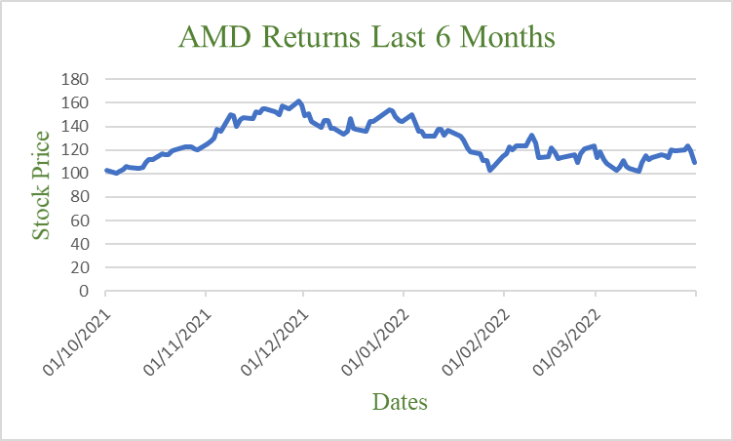

**Appendix:**

(Fig 2.)

(Fig 3.)

(Fig 4.)

(Fig 8.)

(Fig 9.)

(Fig 10.)

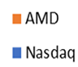

(Fig 11.)

|  |  |
| --- | --- |
| **Beta Calculations:** | |
| 20 Year Intraday Beta | 1.4982 |
| 20 Year Intraweek Beta | 1.762852265 |
| 20 Year Intramonth Beta | 2.099 |
| 10 Year Intraday Beta | 1.488519 |
| 5 Year Intraday Beta | 1.4952 |
| Covid-19 Intraday Beta | 1.378443 |
| Financial Crisis Intraday Beta | 1.348858 |

(Fig 12.)



(Fig 13.)



(Fig 14.)



(Fig 15.)

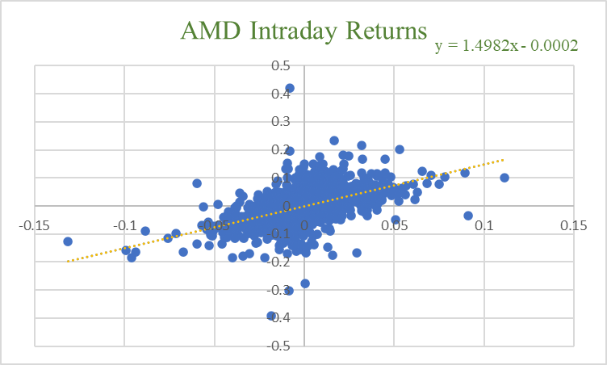

(Fig 16.)

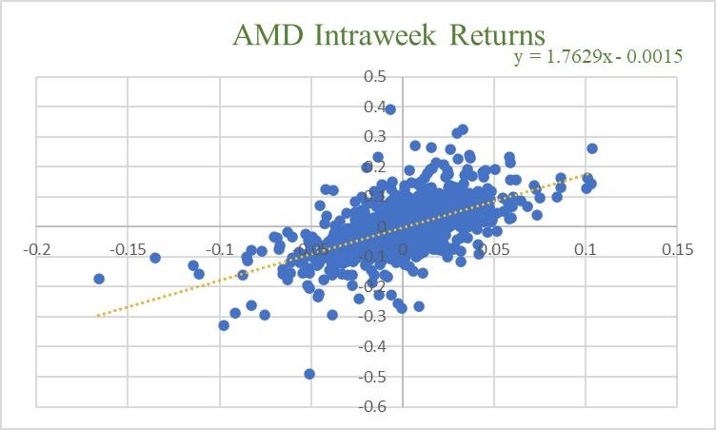

(Fig 17.)

(Fig 18.)

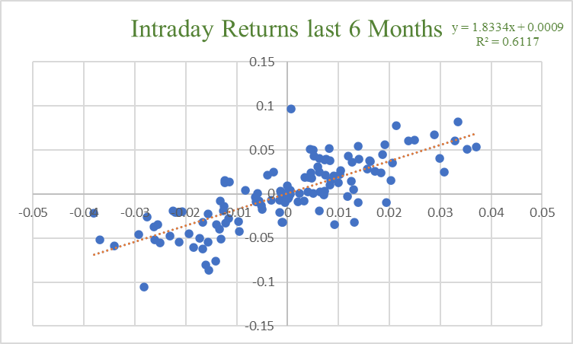

**Calculations:**

**P/E ratio 2022 –** 119.22/2.57 = 46.4

**P/E ratio 2012 –** 8.47/0.1275 = 66.43

**PEG Ratio –** 46.4/47.3 = 0.98

**ROE =** 47.3%

**Bibliography:**

Advanced Micro Devices (2022) *About AMD,* available: <https://www.amd.com/en/corporate/about-amd> [accessed 31 Mar 2022].

Alsop, T. (2021) *Advanced Micro Devices (AMD) - statistics & facts*, Statista, available: <https://www.statista.com/topics/7149/advanced-micro-devices-amd/#dossierKeyfigures> [accessed 31 Mar 2022].

Amarnath, S. and Williams, A. (2021) *Supplying Demand: The Chip Shortage in Macro Context*, Employ America, available: <https://employamerica.medium.com/supplying-demand-the-chip-shortage-in-macro-context-dbf08f622e9a> [accessed 1 Apr 2022].

Baranuik, C. (2022) *Chip shortage: Has Europe's plan arrived too late?,* BBC, available: <https://www.bbc.com/news/business-60554228> [accessed 2 Apr 2022].

Birken, E. B. and Curry, B. (2021) How To Calculate Return On Equity (ROE), available: <https://www.forbes.com/advisor/investing/roe-return-on-equity/> [accessed 1 Apr 2022].

CFI (2022) *What is Beta in Finance?* , available: <https://corporatefinanceinstitute.com/resources/knowledge/valuation/what-is-beta-guide/> [accessed 1 Apr 2022].

CFI (2022) *What is Standard Deviation?,* available: <https://corporatefinanceinstitute.com/resources/knowledge/standard-deviation/> [accessed 1 Apr 2022] .

Knight, W. (2021) *Why the Chip Shortage Drags On and On … and On,* Wired, available: <https://www.wired.com/story/why-chip-shortage-drags-on/> [accessed 1 Apr 2022].

Prairie, D. and Cotter, Ruth. (2014) *AMD Announces Move to Nasdaq,* AMD, available: <https://ir.amd.com/news-events/press-releases/detail/585/amd-announces-move-to-nasdaq> [accessed 31 March 2021].

Sharma, A. (2021) *Skewness & Kurtosis Simplified*, Towards Data Science, available: <https://towardsdatascience.com/skewness-kurtosis-simplified-1338e094fc85> [accessed 1 Apr 2022].

The Motley Fool (2016) *Does Trading Volume Affect Stock Price?* , available: <https://www.fool.com/knowledge-center/does-trading-volume-affect-stock-price.aspx> [accessed 1 Apr 2022].

White, M. (2021) *AMD’s CPU market share hits 15-year high, cuts into Intel’s lead,* Digitaltrends, <https://www.digitaltrends.com/computing/amd-now-controls-its-largest-cpu-market-share-over-intel-in-15-years/> [accessed 31 Mar 2022].

Yahoo Finance (2022) *Advanced Micro Devices, Inc. (AMD)*, available: <https://finance.yahoo.com/quote/AMD?p=AMD&.tsrc=fin-srch> [accessed 31 Mar 2022].

Yahoo Finance (2022) *NASDAQ Composite (^IXIC),* available: <https://finance.yahoo.com/quote/%5EIXIC/history?period1=1633046400&period2=1648771200&interval=1d&filter=history&frequency=1d&includeAdjustedClose=true> [accessed 31 Mar 2022].